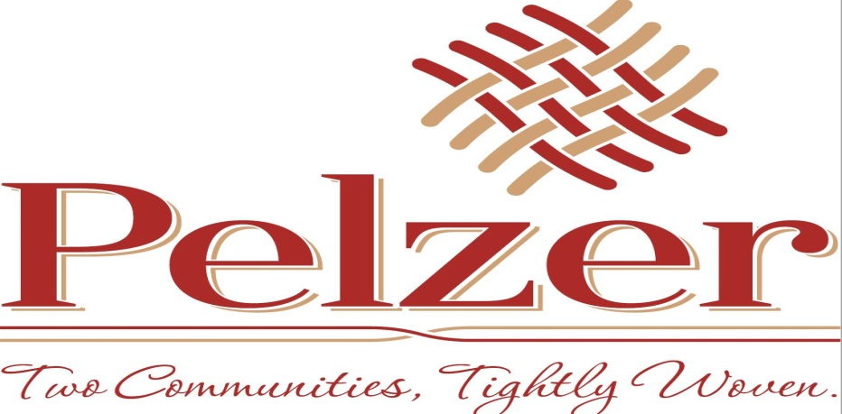

SPECIAL CALLED MEETING
Town of Pelzer
Friday, June 1, 2018 – 4:00 p.m.
Pelzer Town Hall

- INVOCATION

- CALL TO ORDER

- CONTRACTUAL MATTER

- EXECUTIVE SESSION

- ADJOURNMENT

