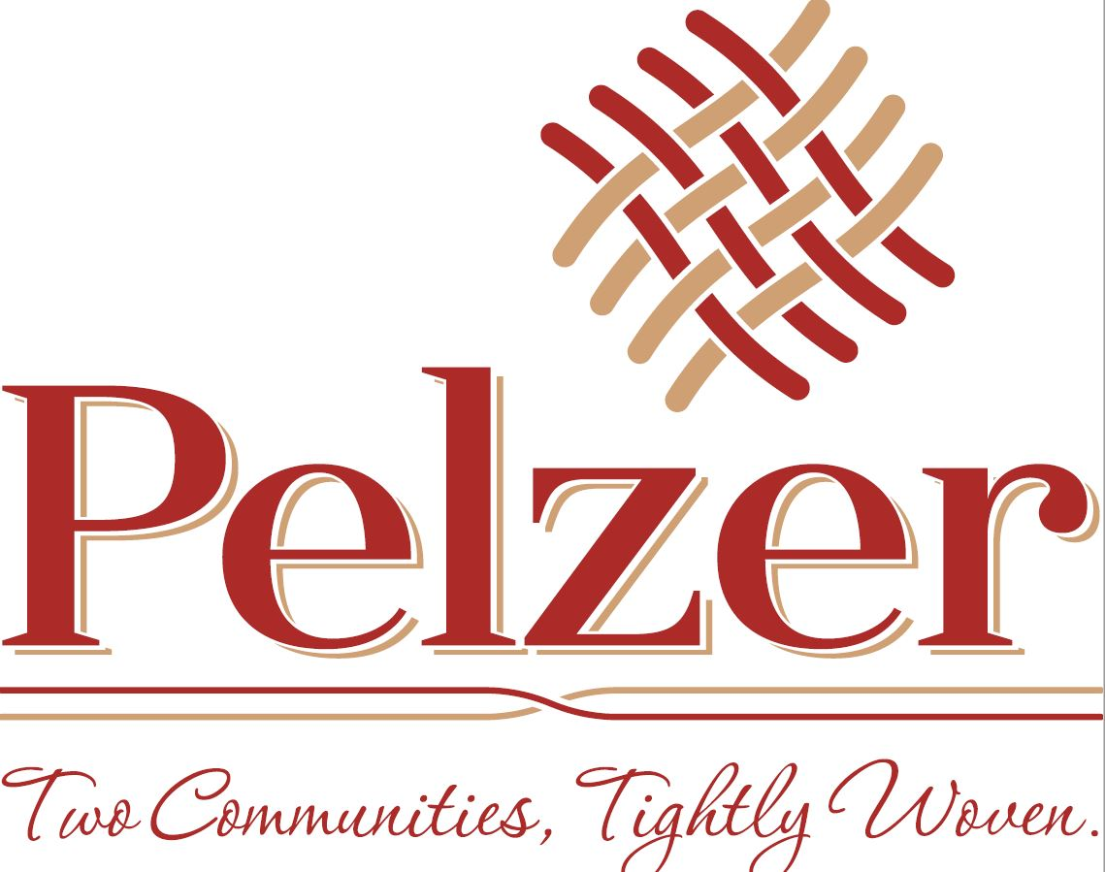

TOWN OF PELZER
103 Courtney Street
Pelzer, SC 29669

ANNUAL BUDGET
FISCAL YEAR 2017-2018
Ordinance 2017-001

Prepared by:

Heather Holcombe
Pelzer Town Clerk

Paula Payton
West Pelzer
Town Clerk/Administrator

May 1, 2017

Dear Members of Town Council and Citizens of the Town of Pelzer, South Carolina:

I am pleased to present to the citizens of the Town of Pelzer, members of Town Council, Town employees, and other interested readers the draft FY2017/2018 operating budget for the Town of Pelzer, South Carolina. A great deal of study and review has been devoted to this budget. Heather has provided monthly/yearly reports to assist in gathering the information you are being presented.

The focus of the FY2017/2018 annual budget is to continue to provide a high level of service for traditional services while building on the successes of the previous budget year. The major services include Administration and Public Works. Our goal is to maintain the Town’s quality and level of service, improve the Town’s financial position, and embrace a more equitable and sustainable manner for funding Town services.

The budget for all funds is $917,012.42, an increase over last fiscal year. A summary of all funds is included as part of this budget package. Achieving a balanced budget may require many meetings and discussion between Department Heads and Town Council before a final adopted budget is in place.

Conclusion
The Town of Pelzer can be proud of the many accomplishments and can look forward to another year of providing excellent service to your community. The following budgetary information is a breakdown of actual expenditures. Please review this information in detail prior to the budgeting workshop.

Sincerely,

Heather Holcombe
Pelzer Town Clerk

Paula H. Payton, CMC
Paula H. Payton, CMC
West Pelzer Town Clerk / Administrator

Budget Requirement

In accordance with the General Statutes of the State of South Carolina, the Town Council is required to adopt an annual balanced budget prior to July 1st. The Town uses the adopted budget as a management control device during the year. A balanced budget is achieved when the Town is able to equate the revenues with expenditures over the business cycles.

Budget Preparation Calendar
Fiscal Year 2017-2018
May Informal Submittal to Town Council (prior to Council Meeting)
May Formal Budget Presentation and Workshop with Town Council – 1st Reading
May/June Public Hearing
June Adopted Budget Ordinance – 2nd Reading
July FY17/18 Budget Year Begins (Adopted Budgets Distributed)

General Fund Revenue

Mission
The General Fund Revenue is comprised of rental income, state and federal shared revenue. This fund is utilized to operate general government administration.

Goals and Objectives
Through proper planned expenditures, the Town of Pelzer desires to maintain a Fund Balance equitable with monthly expenditures. Future revenue increases should be planned to equate to inflation, salary increases, and increased services.

General Fund Income | FY 16/17 Budget | FY 17/18
Rental Income |  | $23,904.55
Franchise Fees |  | $67,312.00
Miscellaneous Income |  | $2,987.00
Municipal Association of SC |  | $74,686.00
Aid to Subdivisions |  | $1,535.64
Accommodations Tax |  | $1,153.00
Community Building |  | $4,800.00
Total Income to General Fund | $189,749.00 | $176,378.19

Public Works Fund Revenue

Mission
The Public Works Revenue is comprised of monthly fees utilized to operate a fully functional Public Works Department on a daily basis. In prior years, the Public Works Department was solely a department focused on infrastructure needs. With the Town’s increase in new infrastructure, the Public Works Department is expanding to include Parks and Streets. This increased responsibility is not reflected as an increase to revenue or expenses.

Goals and Objectives
Through proper planning, the Town of Pelzer desires to maintain a Fund Balance equitable with expenditures to ensure proper cash flow within the department. Future revenue increases are based on increases executed by REWA and Greenville Water. For FY2017-2018 no increases are expected from REWA or Greenville Water and no increase in fees will be passed to the citizens of Pelzer.

Capital Projects / Reserve
This line item should be reserved for potential grant match for water line replacement.

Income to Public Works | FY 16/17  Actual | FY 17/18
Customer Meter Deposits |  | $5,000.00
Water/Sewer Billings |  | $693,512.00
Miscellaneous Income |  | $3,500.00
Total Income to Water/Sewer | $1,240,631.58 | $702,012.00

Hospitality Fund Revenue

Mission
The Hospitality Fund Revenue is comprised of a 2% tax imposed on prepared foods. This fund is utilized to operate parks, recreation, and tourism activities.

Goals and Objectives
The Town of Pelzer has the ability to bond up to 100% of their hospitality tax collections for capital improvement projects related to tourism.

Hospitality Income | FY 16/17  Actual | FY 17/18
Hospitality Tax Deposit |  | $43,422.23
Total Income to Hospitality | $43,422.23 | $43,422.23

General Fund Expenses
Mission
The General Fund Expense is administrative and operations expenses for general administration, Mayor and Council. The mission of the General Fund Expenditures is to serve the residents and businesses of the Town of Pelzer.

Expense to General Fund | FY 16/17 Actual | FY 17/18
Salaries (Administration) - 1 FT All Expenses |  | $44,339.28
Salaries (Council) |  | $4,800.00
Salaries (Mayor) |  | $2,400.00
Credit Card Payment Fees |  | $1,252.23
Workers Compensation Insurance |  | $486.23
Advertising/Public Notice |  | $42.00
Postage |  | $300.00
Utilities (GF) |  | $2,000.00
Street Lights – Duke Energy |  | $26,355.38
Contingency Expense / Recreation |  | $32,000.00
Travel/Training/Meals (GF) |  | $500.00
Office Expenses |  | $1,000.00
Property / Vehicle Liability |  | $5,835.00
Security – Council Meetings |  | $400.00
Professional Services (GF) |  | $9,000.00
Bank Fees |  | $728.17
Capital Projects / Reserve |  | $44,939.90
Total Expense to General Fund | $117,741.69 | $176,378.19

Public Works Fund Expenses
Mission
The Public Works Fund Expense is administrative and operations expenses for to provide water and sewer services for residents and businesses of the Town of Pelzer.

Salaries – The salaries line item is inclusive of salary, insurance, retirement and payroll taxes and reflects to raises. The decrease in salaries expense is a result of the joint Public Works Department shared with the Town of West Pelzer; Pelzer’s portion is 55% of total expense ($112,603.07)

Expense to Public Works | FY 16/17 Actual | FY 17/18
Salaries - 3 FT All Expenses |  | $61,931.69
Credit Card Payment Fees |  | $3,157.75
Postage |  | $500.00
Permit Fees |  | $500.00
Utilities |  | $53,605.72
SCDHEC Fees |  | $3,000.00
QS1 |  | $8,400.00
Advertising/Public Notice |  | $1,000.00
Sanitation Contract Agreement |  | $47,040.00
Parts, Supplies, Repairs/Maintenance |  | $5,000.00
Chemicals |  | $6,000.00
Professional Services |  | $50,000.00
Water Contract Agreement – Greenville Water |  | $93,566.76
Contingency |  | $5000.00
Office Supplies |  | $500.00
Uniforms |  | $247.50
Travel, Training and Meals |  | $300.00
Vehicle/Equipment Fuel |  | $1,500.00
Vehicle/Equipment Repairs |  | $3,000.00
Debt Service (RD Sewer Project) |  | $93,828.00
Workers Compensation Insurance |  | $486.81
Maintenance/Grass |  | $14,700.00
REWA Payment |  | $196,800.00
Capital Projects / Reserve |  | $96,718.49
Total Expenses to Water/Sewer | $589,565.42 | $702,012.00

Hospitality Fund Expenses

Mission
The mission of the Hospitality Fund is to promote activity as it relates to parks, recreation, and tourism.

Hospitality Expense |  | FY 17/18
Parks |  | $6,598.03
Christmas Parade |  | $200.00
Gym |  | $2,751.32
Community Building |  | $9,103.68
Miscellaneous |  | $4,890.00
Beautification and Maintenance |  | $19,879.20
Total Expense to Hospitality |  | $43,422.23

