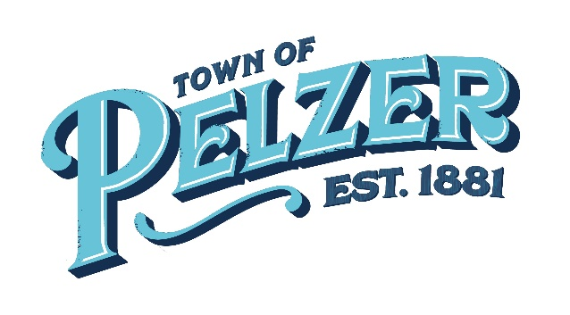
COUNCIL MEETING AGENDA
Tuesday, Oct 11, 2022 – 6:00pm
Pelzer Gym Lobby – 112 Lebby Street

- CALL TO ORDER

- INVOCATION/PLEDGE OF ALLEGIANCE

- CITIZEN COMMENTS (sign up required – 3 minutes)

- APPROVAL OF MINUTES
  - Sept 13 Council Meeting

- CLERK’S REPORT/PRESENTATIONS
  - Cheryl Boudreau – Clerk’s Report
  - Richard Thompson – Attorney’s Report

- OLD BUSINESS - none

- NEW BUSINESS
  - Additional streetlights

- ANNOUNCEMENTS
  - Planning Commission –Wed, Oct 19 at 6pm
  - Anderson County Parks and Recreation master plans for Timmerman Landing and Monkey Park. Tuesday, Oct 25, community input at 6pm.

- EXECUTIVE SESSION
*Council may take election following executive session on matters discussed in executive session.

- REQUEST BY COUNCIL

- ADJOURNMENT

