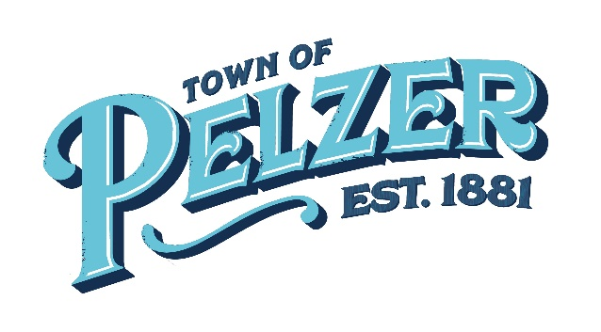
COUNCIL MEETING AGENDA
Tuesday, Dec 13, 2022 – 6:00pm
Pelzer Gym Lobby – 112 Lebby Street

- CALL TO ORDER

- INVOCATION/PLEDGE OF ALLEGIANCE

- CITIZEN COMMENTS (sign up required – 3 minutes)

- APPROVAL OF MINUTES
  - Nov 15 Council Meeting

- CLERK’S REPORT/PRESENTATIONS
  - Cheryl Boudreau – Clerk’s Report
  - Richard Thompson – Attorney’s Report

- OLD BUSINESS
  - 2nd Reading of Ordinance PC-002 – Adopting the 2022-23 Town of Pelzer Comprehensive Plan, with amendments

- NEW BUSINESS
  - Approval of auditor for FY22
  - Approval of Council meeting times for 2023

- ANNOUNCEMENTS
  - Greenville Water Public Meeting – January 17

- EXECUTIVE SESSION
*Council may take election following executive session on matters discussed in executive session.

- REQUEST BY COUNCIL

- ADJOURNMENT

